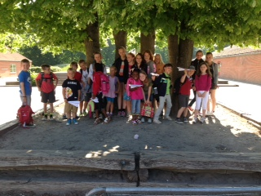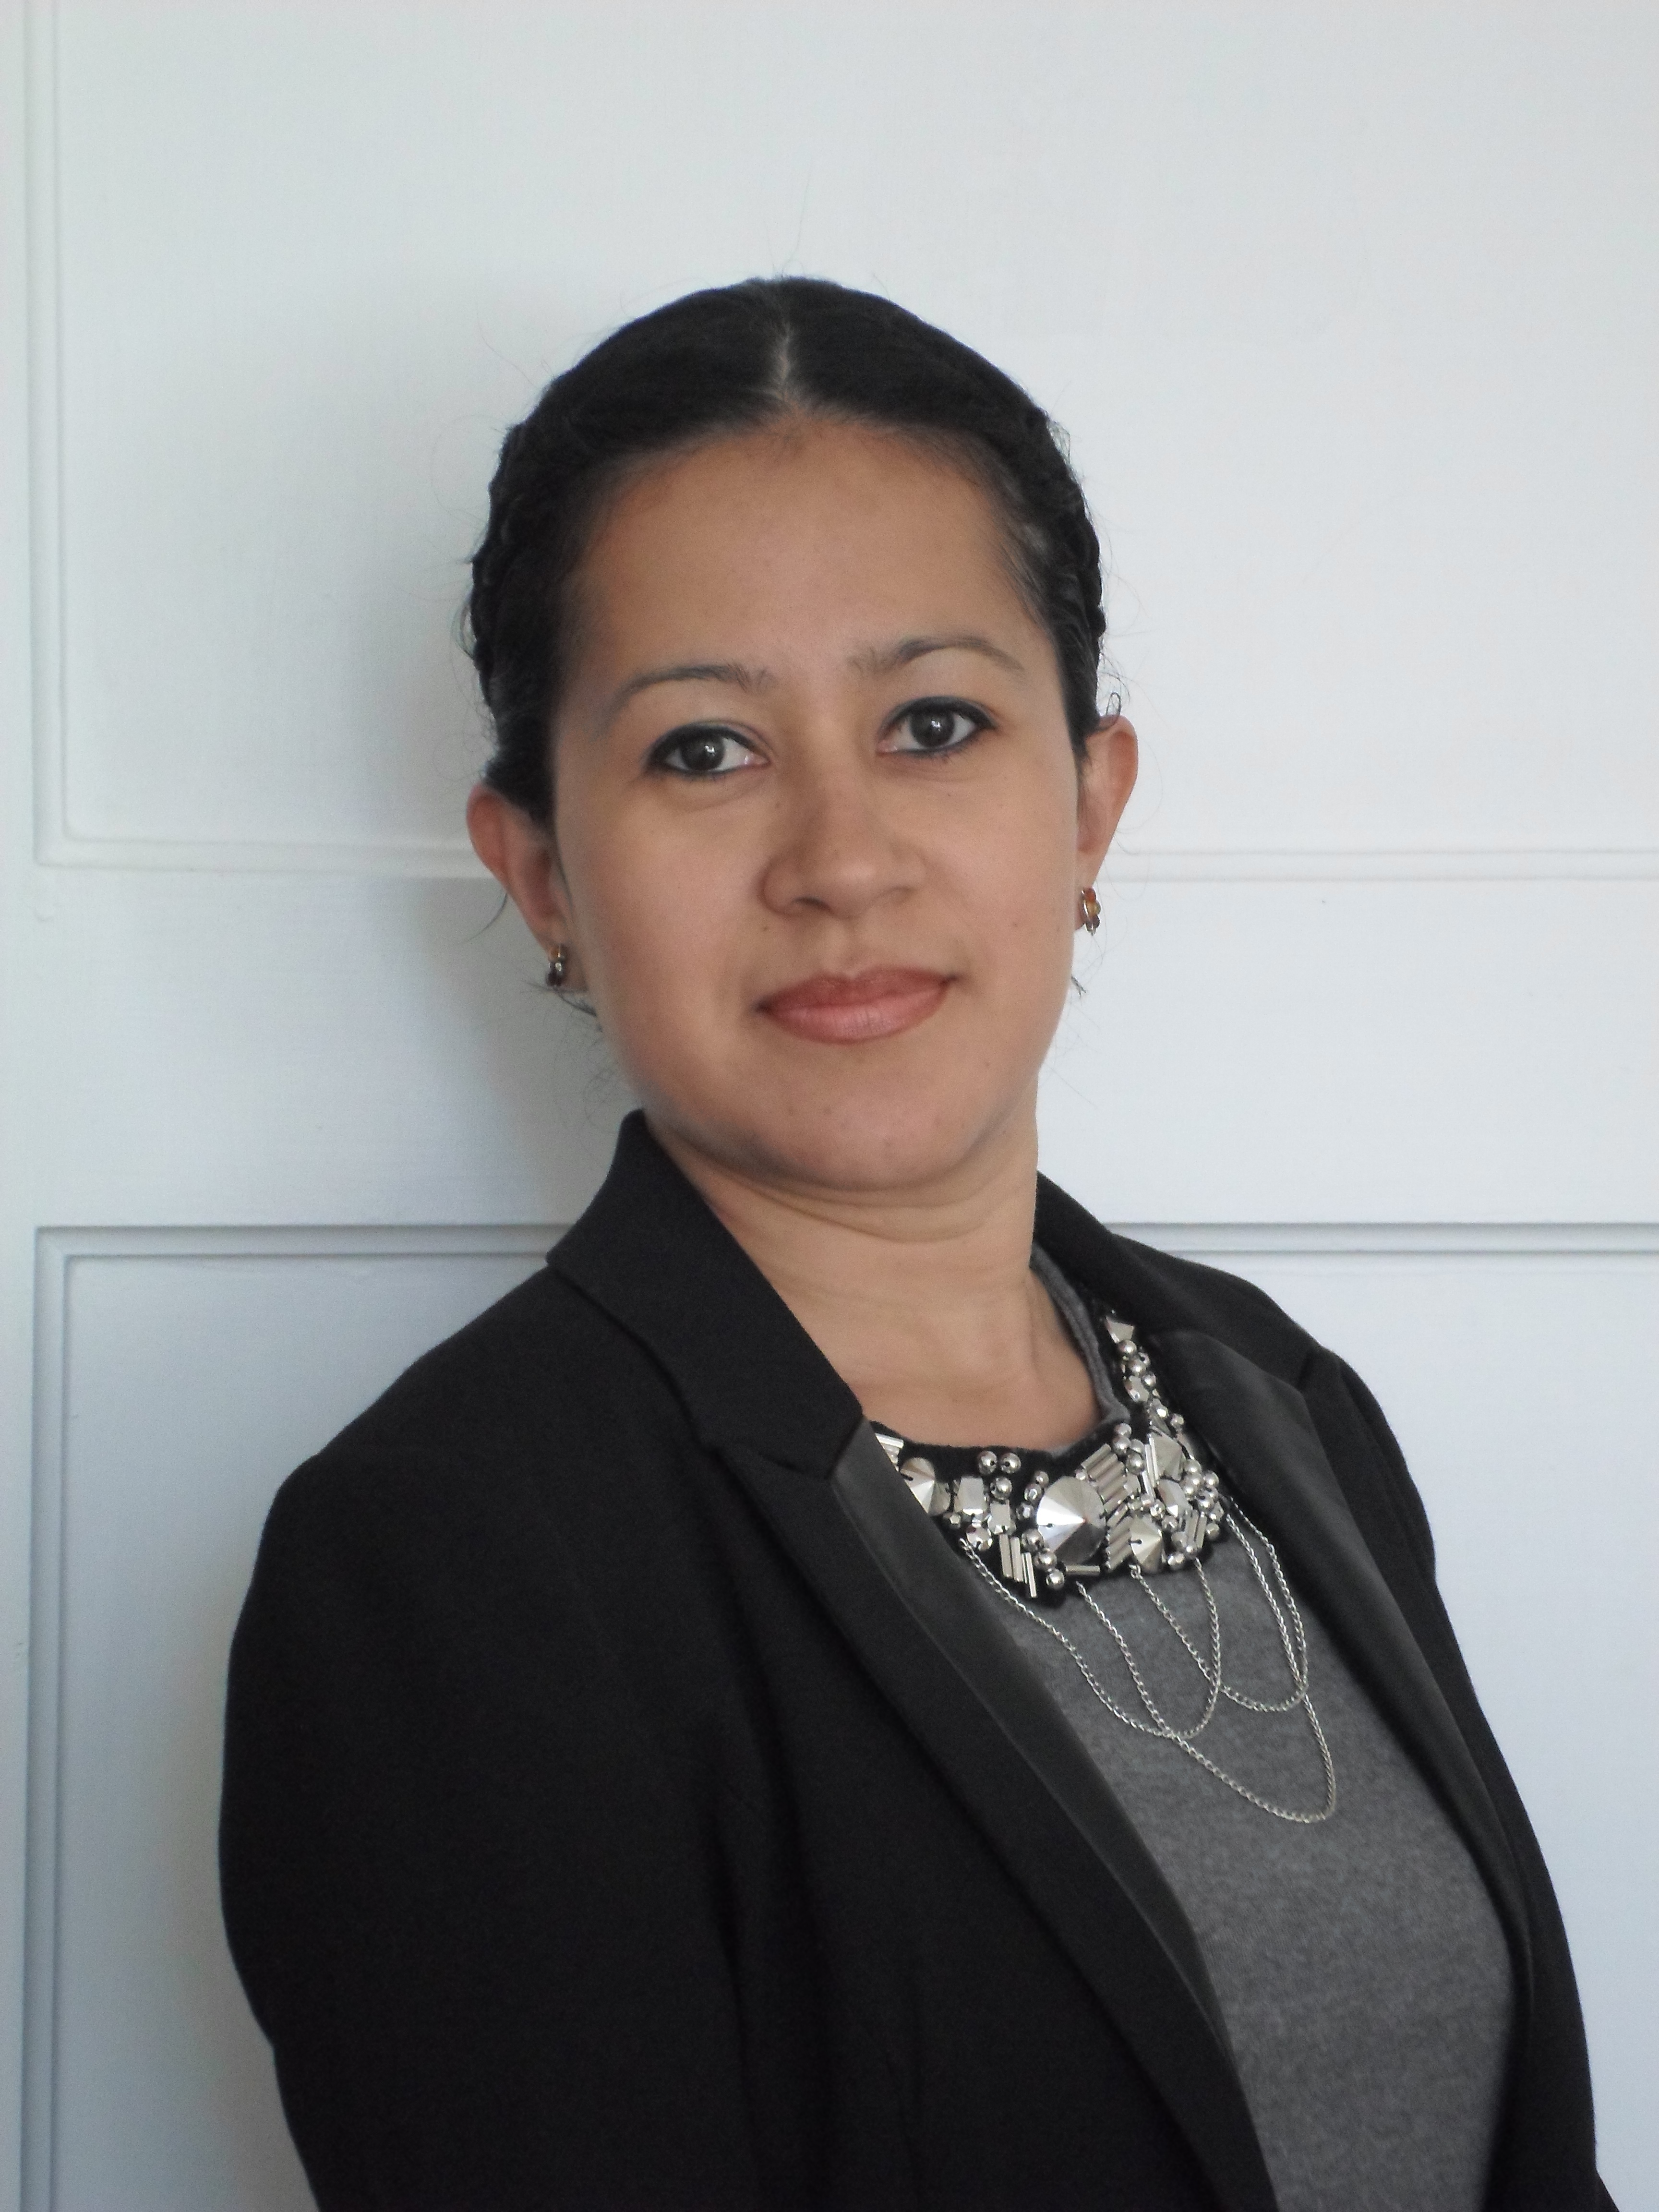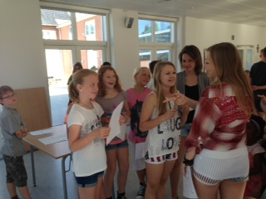

Dear Parents,   
  
While the focus week is ongoing and the students are learning through new experiences, we are also in the middle of preparing next school year.

Thank you for your feedback on the inquiry form about languages. The majority prefer Spanish and therefore I am glad to announce that we next year offer Spanish to Secondary 1. Our new teacher is Marisol and here is a brief introduction from her.

*I´m a native Spanish speaker from Mexico. I began working in 2005 as a Professor of Spanish, teaching a range of students at Beginner, Intermediate and Advanced Spanish levels. I have been teaching Spanish as a foreing language for the past years. I have also been responsible for University Programmes such as Wisconsin, Washington, Stevens Point, Pacific Lutheran, Madison, Montana, Indiana and others. Classes will be taught in Spanish and I will clarify the differences between Spanish from Spain and Latin America.*

We also welcome Dominic Maher, no picture, but you will get to meet him right at the beginning of the new school year as P2 English teacher and History teacher in Secondary 1.

Sharon and Tim who have been around for the last couple of months as co-teachers are looking forward to their new role as contact teachers. Tim will be contact teacher for P2and Sharon for P1.

Michelle and Geraldine have a shared contact teacher function in Secondary 1.

We expect to release timetables to students before the break. These wil also show the joint time slots shared by some subjects which are always a puzzle in international schools.

**Important!**

**Please write an email to** [**berit@sktjosef.dk**](mailto:berit@sktjosef.dk) **if your child has been baptised in the Catholic church**

7B and Int. Dept. doing a role play

Upcoming Events

June 21, last Coffee Club for this year

June 28, last day of school from 10.00-11.30. Classes are then dismissed and SFO takes over.

**Marisol**

12/6/2013

No 8– Focus week

Newsletter from

the International

Department

*Skt. Josef’s School*